# mlew logo

# IOT WORK SHOP

## DAY-3

ASSOCIATED BY:- MAKE SKILLED



## TEAM NAME:- SMART CREATORS

TEAM MEMBERS:- CH.ALEKHYA GAYATRI(24KE5AO404)

1. HIMA BINDU (24KE5A0406)
2. TRISHA (24KE5A0405)
3. PRIYA (23KE1A0450)
4. SIVA PARVATHI (23KE1A0431)

# ACTIVITY-13

# Q.ROTATING SERVO MOTOR TO 0 TO 90 AND 90 TO 0

## REQUIRED COMPONENTS:-

**ESP32**

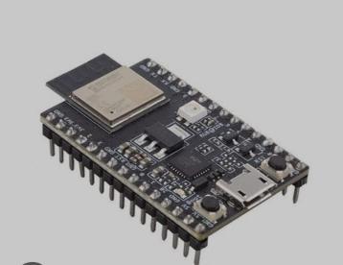

**SERVO MOTOR**

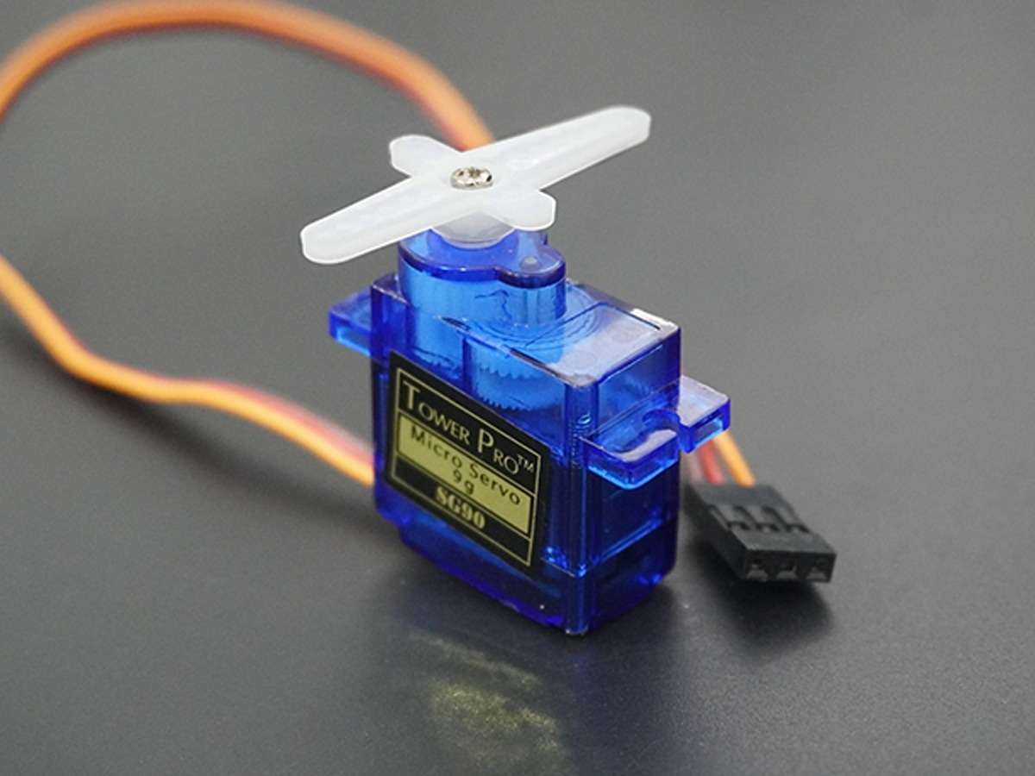

**USB CABLE**

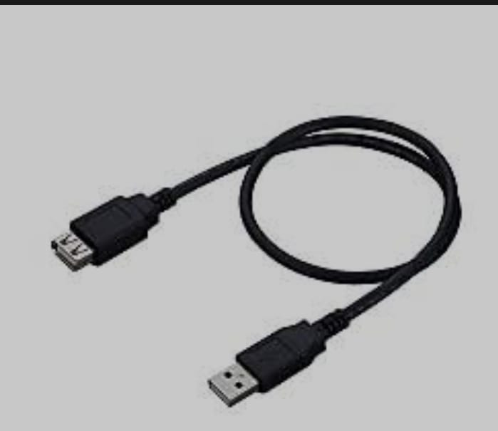

**JUMPER WIRES**

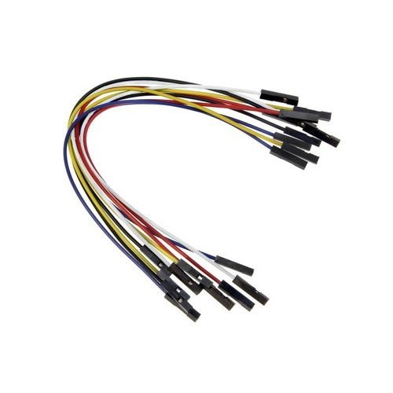

**MALE AND FEMALE JUMPER WIRES**

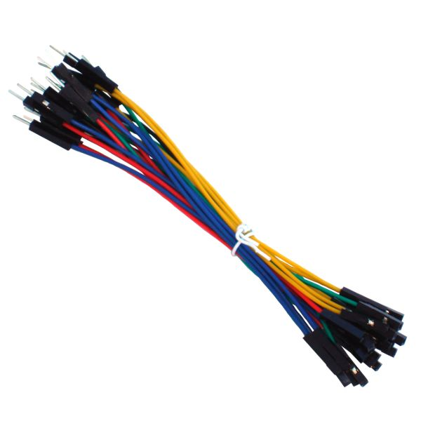

## CONNECTIONS:-

* Brown wire of the servo motor is connected to the GND of the ESP32 .
* Red wire of the servo motor is connected to the VCC of the ESP32 .
* Yellow wire of the servo motor is connected to the PIN D2 of the ESP32 .

## CODE:-

#include<ESP32Servo.h>

Servo myServo ;

void setup() {

myServo.attach(2);

// put your setup code here, to run once:

}

void loop(){

myServo.write(90);

delay(5000);

myServo.write(0);

delay(5000);

// put your main code here, to run repeatedly:

}

## OUTPUT:-

* Before compile the code we have to install ESP32 servo library,after that compile the code.
* Code will be dumped on the ESP32 after that connect all connections.
* Then the output will be the servo motor is turns 90 degrees after 5 sec of time delay the servo motor turn 0 degrees.

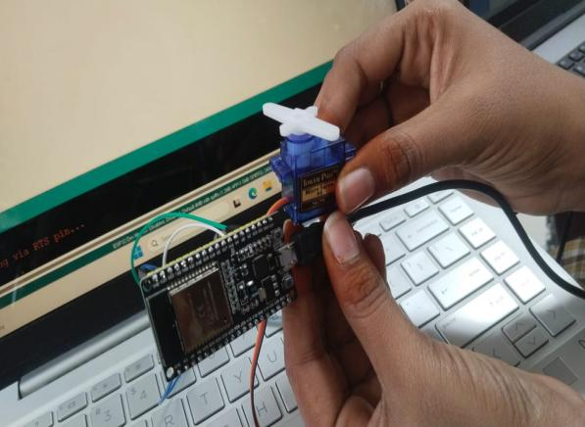 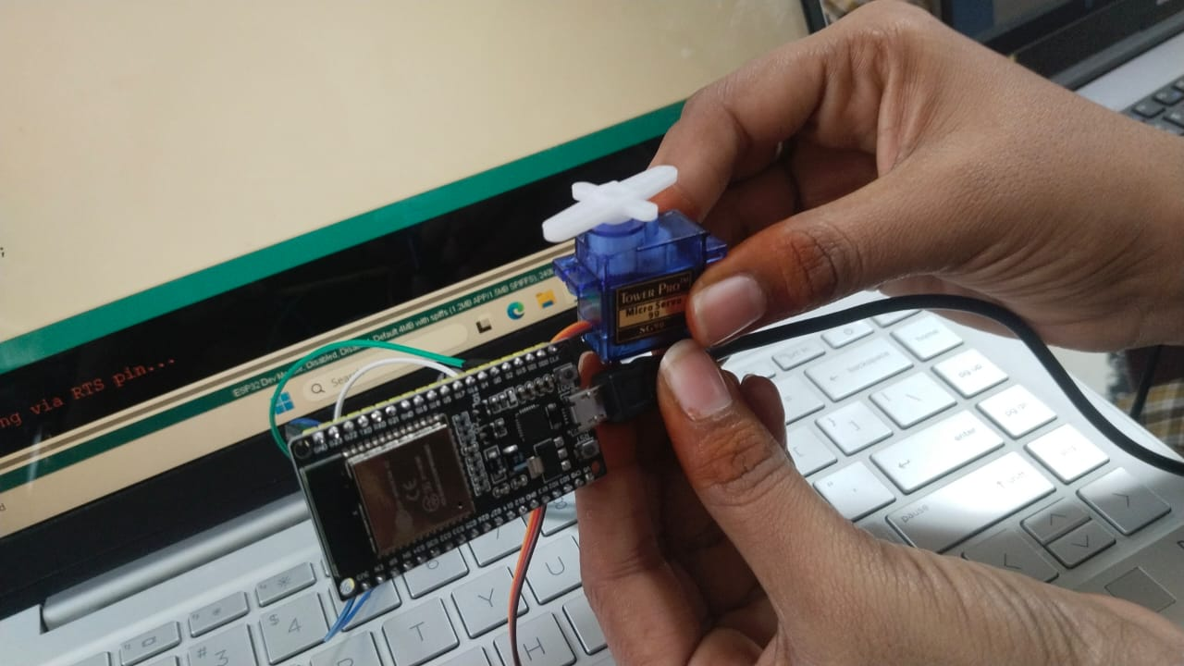

# ACTIVITY-14

# Q.INTEGRATING SOIL MOISTURE SENSOR WITH SERVO MOTOR ROTATES 0 AND 90

## REQUIRED COMPONENTS:-

**ESP32**



**SERVO MOTOR**



**USB CABLE**



**JUMPER WIRES**

## ff

**MALE AND FEMALE JUMPER WIRES**



**SOIL MOISTURE SENSOR WITH FISH SENSOR**

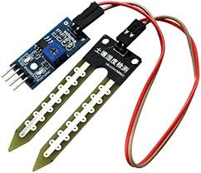

## CONNECTIONS:-

* Brown wire of the servo motor is connected to the GND of the ESP32 through the male to female wire.
* Red wire of the servo motor is connected to the VCC of the ESP32 through the male to female wire.
* Yellow wire of the servo motor is connected to the PIN D2 of the ESP32 through the male to female wire.
* A0 PIN of the soil moisture sensor is connected to the D34 of the ESP32.
* GND PIN of the soil moisture sensor is connected to the GND PIN of the ESP32.
* VCC PIN of the soil moisture sensor is connected to the VCC PIN of the ESP32.

## CODE:-

**#include<ESP32Servo.h>**

**int soil = 34;**

**int threshold = 4095;**

**Servo myServo;**

**void setup() {**

**myServo.attach(2);**

**pinMode(soil,INPUT);**

**Serial.begin(9600);**

**// put your setup code here, to run once:**

**}**

**void loop() {**

**int g = analogRead(soil);**

**Serial.println(g);**

**if(g<threshold){**

**Serial.println("moisture detected");**

**myServo.write(0);**

**// put your main code here, to run repeatedly:**

**}**

**else{**

**Serial.println("no moisture detected");**

**myServo.write(90);**

**}**

**}**

## OUTPUT:-

* Code will be dumped on the ESP32 after that connect all connections.
* When the soil moisture sensor detects moisture prints the output moisture detected and the servo motor is in OFF state.
* When the soil moisture sensor detects no moisture prints the output no moisture detected and the servo motor is in ON state.

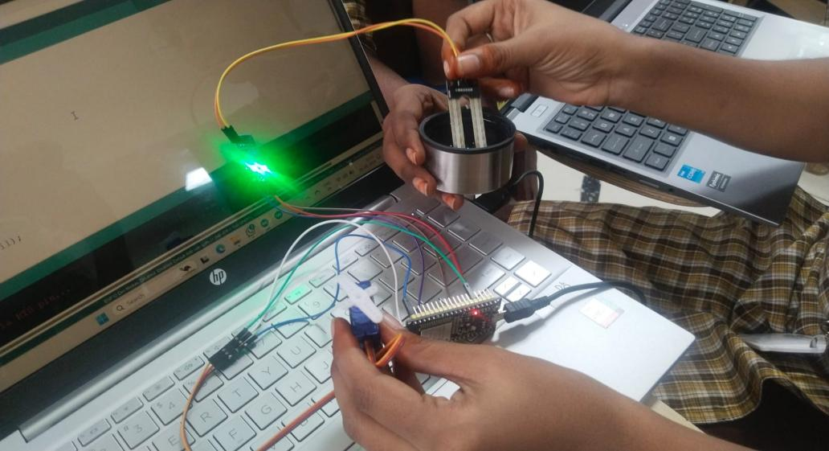

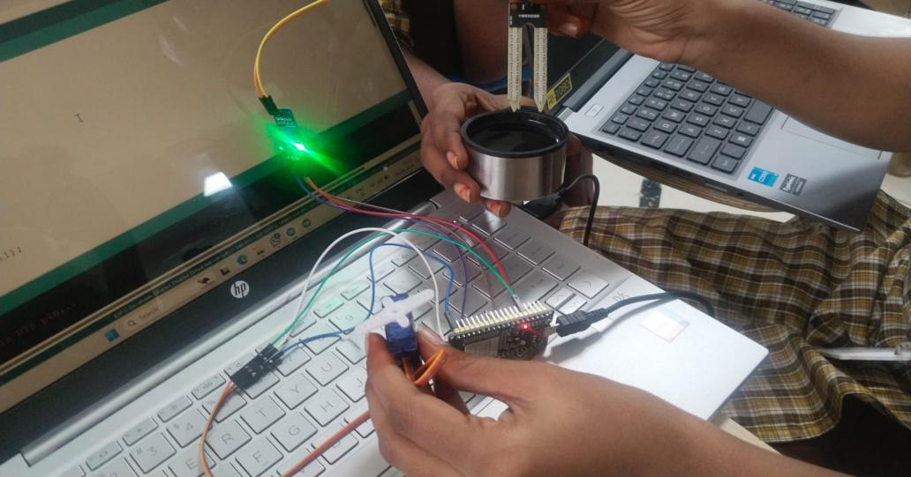

# ACTIVITY-15

# INTEGRATING SOIL MOISTURE SENSOR WITH BUZZER

## REQUIRED COMPONENTS:-

**ESP32**



**USB CABLE**



**JUMPER WIRES**

## ff

**SOIL MOISTURE SENSOR WITH FISH SENSOR**



**BUZZER**

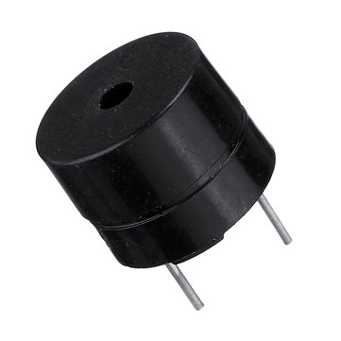

## CONNECTIONS:-

* 0 PIN of the soil moisture sensor is connected to the D34 of the ESP32.
* GND PIN of the soil moisture sensor is connected to the GND PIN of the ESP32.
* VCC PIN of the soil moisture sensor is connected to the VCC PIN of the ESP32
* +PIN of the buzzer is connected to the D12th PIN of the ESP32 PIN.
* -PIN of the buzzer is connected to the GND PIN of the ESP32.

## CODE:-

int soil = 34;

int threshold = 402;

int buzzer = 12;

void setup() {

pinMode (soil,INPUT);

pinMode (buzzer,OUTPUT);

Serial.begin(9600);

// put your setup code here, to run once:

}

void loop() {

int a = analogRead(soil);

Serial.println(a);

if(a<threshold){

Serial.println("moisture decteted");

digitalWrite(buzzer,0);

}

// put your main code here, to run repeatedly:

else{

Serial.println("no moisture decteted");

digitalWrite(buzzer,0);

  }

## OUTPUT:-

* Code will be dumped on the ESP32 after that connect all connections.
* When the soil moisture sensor detects moisture prints the output moisture detected and the buzzer is in OFF state.
* When the soil moisture sensor detects no moisture prints the output no moisture detected and the buzzer is in ON state

# ACTIVITY-16

# Q.INTEGRATING GAS SENSOR WITH LDR SENSOR

## REQUIRED COMPONENTS:-

**ESP32**



**USB CABLE**



**JUMPER WIRES**



**GAS SENSOR**

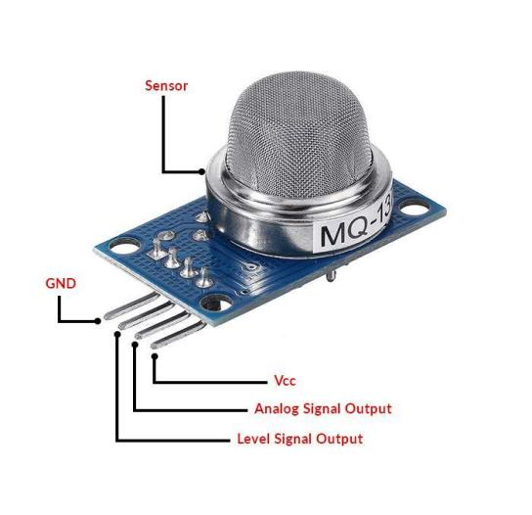

**LDR SENSOR**

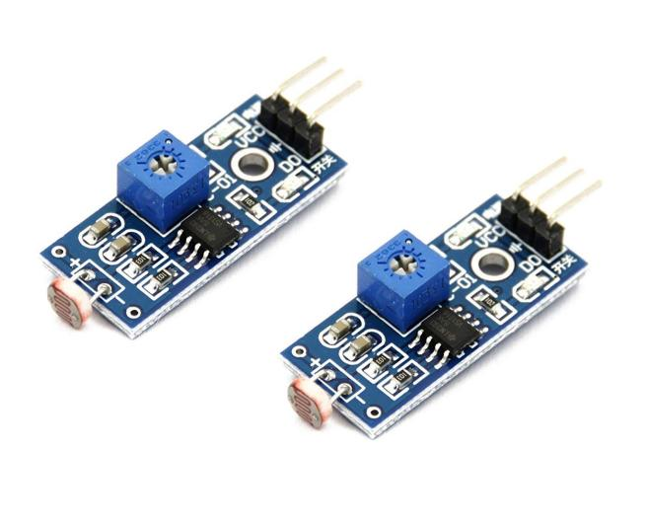

## CONNECTIONS:-

* The A0 PIN of the gas sensor is connected to the D34 PIN of the ESP32.
* The GND PIN of the gas sensor is connected to the GND PIN of the ESP32.
* The VCC PIN of the gas sensor is connected to the VCC PIN of the ESP32.
* The D0 PIN of the LDR sensor is connected to the D12 PIN of the ESP32.
* The GND PIN of the gas sensor is connected to the GND PIN of the ESP32.
* The VCC PIN of the gas sensor is connected to the VCC PIN of the ESP32.

## CODE:-

int gas = 34;

int threshold = 2000;

int ldr = 12;

void setup() {

pinMode(gas,INPUT);

pinMode(ldr,INPUT);

Serial.begin(9600);

}

void loop() {

int a1 = analogRead(gas);

Serial.println(a1);

int a2 = digitalRead(ldr);

Serial.println(a2);

if(a1<threshold){

Serial.println("Harmful gas detected");

}

else{

Serial.println("No gas detected");

}

if(a2 == 1){

Serial.println("Dark detected");

}

else{

Serial.println("Dark detected");

}}

OUTPUT:-

* Code will be dumped on the ESP32 after that connect all connections.
* When the gas sensor detected harmful gas then print the output on serial monitor as harmful gas detected.
* When the gas sensor detected not harmful gas then print the output on serial monitor as no harmful gas detected.
* When the LDR sensor detects dark then the output is 1 and prints the statement dark detected.
* When the LDR sensor detects light then the output is 0 and prints the statement light detected.

# ACTIVITY-17

# Q . CONNECTING WIFI WITH ESP32

**ESP32**



**USB CABLE**



**DATA HOTSPOT**

## CONNECTIONS:-

* Connect the cable laptop to ESP32

## CODE:-

#include<WiFi.h>

const char * ssid = ("Buddiii");

const char * passward = ("6309846308");

void setup() {

Serial.begin(9600);

WiFi.mode(WIFI_STA);

WiFi.begin(ssid,passward);

Serial.println("WiFi connecting");

while(WiFi.status()!=WL_CONNECTED){

delay(5000);

Serial.println(".");

}

Serial.println("WiFi connected");

}

void loop() {

// put your main code here, to run repeatedly:

}

OUTPUT:-

* **The connecting Wi-Fi with ESP32, the WIFI hotspot must have unlimited connections.**
* **Hotspot user name password not contain special characters.**
* **When the ESP32 is connected to WI-FI hotspot then prints the output in serial monitor WiFi connected**

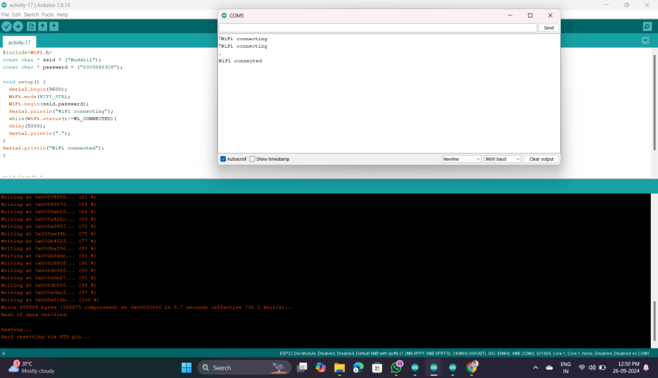

# ACTIVITY-18

# Q . CREATE ACCOUT ON THINGSPEAK.COM

## PROCESS:-

* Go to chrome and search the thingspeak.,com
* Click get started
* Click create one
* Enter your Email id and fill the details.
* Go to Email verify math works Email.
* Set your strong password and click on continue.
* Then signed in thingspeak.com successfully and click ok.